**Requirements for Maven and Installing Maven?**

The main requirement for installing maven is java.

Because maven was developed in java, java should be installed on your system and paths should be set up.

**Installing Maven:**

For installing maven, go to google and search for “Maven Download”. You will get the first result for downloading the maven.

Or you can go to the following url and you can download it.

<https://maven.apache.org/download.cgi>

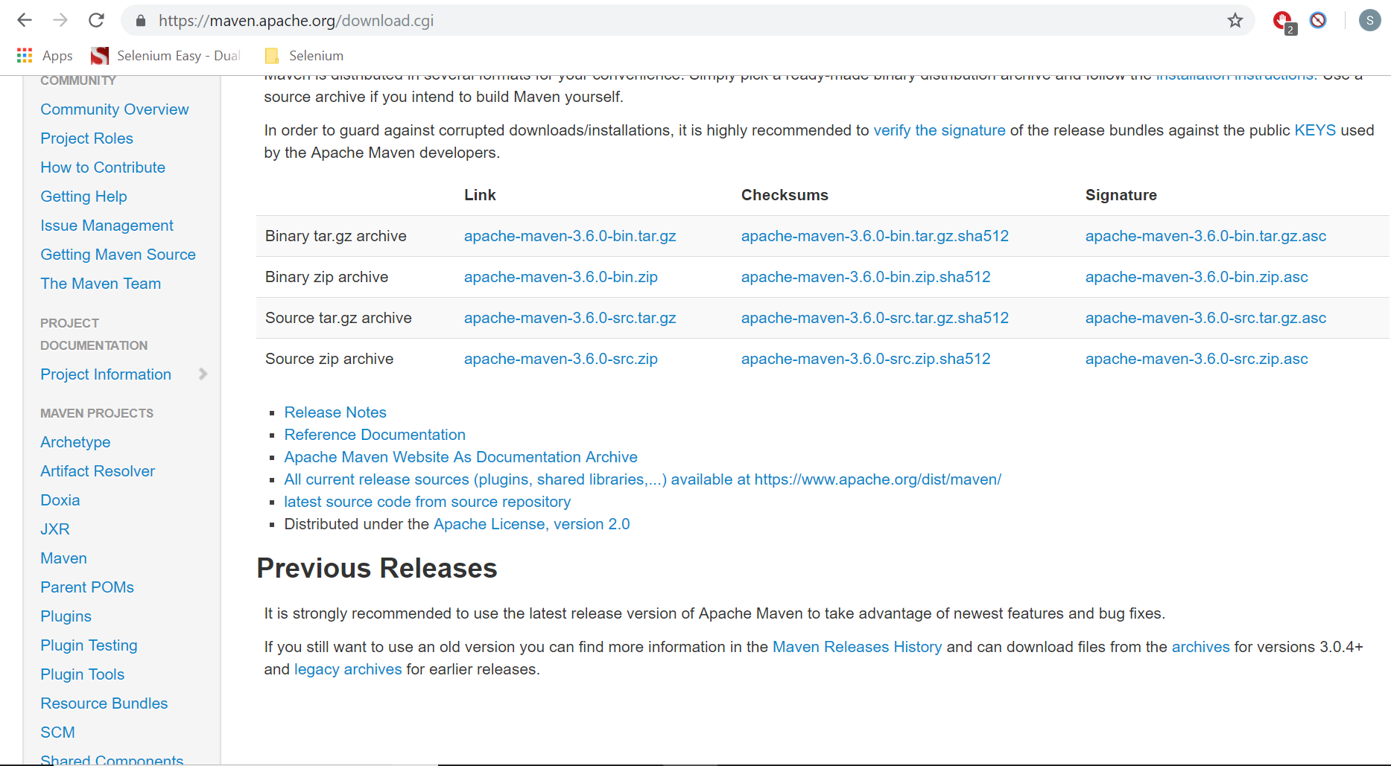

Download the binary zip file and unzip it.

Once you unzip it in any folder, you need to set up environment variables.

Go to Advanced settings, environment variables and go to system variables.

You need to se the following two system variables.

MAVEN_HOME – Set the home path (The folder where you have unzipped Maven)

Path – Add the bin folder path to this.